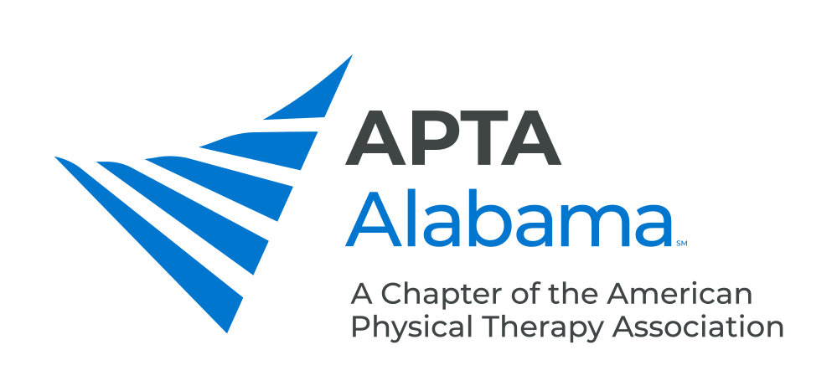
CHAPTER COUNCIL REPORT

Office, Committee or SIG: Chapter Bylaws Committee

Submitted by: Blair Saale | Date: 7/22/24
Please list your accomplishments since the last report:

- We became compliant with the APTA Model bylaws
- Sending out proposed amendment to allow PTAs to serve as a Delegate

