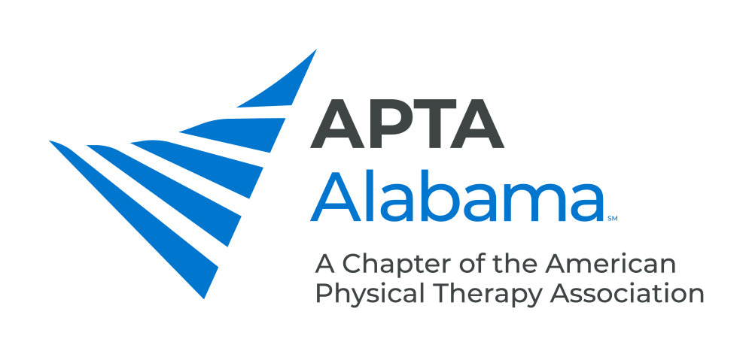
CHAPTER COUNCIL REPORT

Office, Committee or SIG: Delegates

Submitted by: Andrea Bowens (Chief Delegate) | Date: 8/12/2024
Please list your accomplishments since the last report:

- Delegates for the 2024 House include: Andrea Bowens (Chief), Matt Matlock, and Lesley Parrish. Kendell Jno-Finn and Don Lein will serve as Alternate Delegates.
- Chief Delegate (Andrea Bowens) continues to participate in monthly Chief Delegate calls with House Officers.
- Alabama delegates and PTA Council Rep had five virtual meetings from April through July to discuss preparations for the 2024 House of Delegates and current motion concepts.
- Delegates attended the virtual House of Delegates session on April 13th and in-person House of Delegates session from July 21st-22nd in Kansas City, MO. The House considered 24 motions and passed 17 motions. Alabama delegates surveyed members and non-members to gather feedback on topics that were going to be discussed at the in-person House session. The summarized responses were provided to House officers and will be included in a larger summary of feedback to APTA.
- The slate of candidates for national office is now posted online and the delegates will review candidate materials and interviews when it becomes available. The delegates will meet to discuss candidates for national office and plan to participate in the virtual elections on November 7th.

