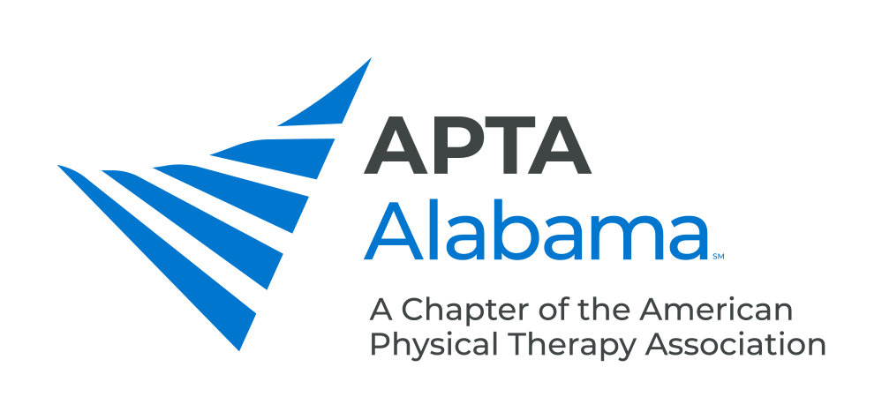
CHAPTER COUNCIL REPORT

Office, Committee or SIG: Membership Committee

Submitted by: Macie Frederick | Date: 8/12/2024, late, sorry ☹
Please list your accomplishments since the last report:

- We have hosted multiple successful PT Night Outs this year.
- We have added members to the Membership committee
- We are working with the student SIG to hit all PTA and PT schools this fall, most are already scheduled with PT Night Out Events the same.
- We had our first PT Night Out event in Dothan, AL.
- Continuing to focus on building the team to increase out reach.

