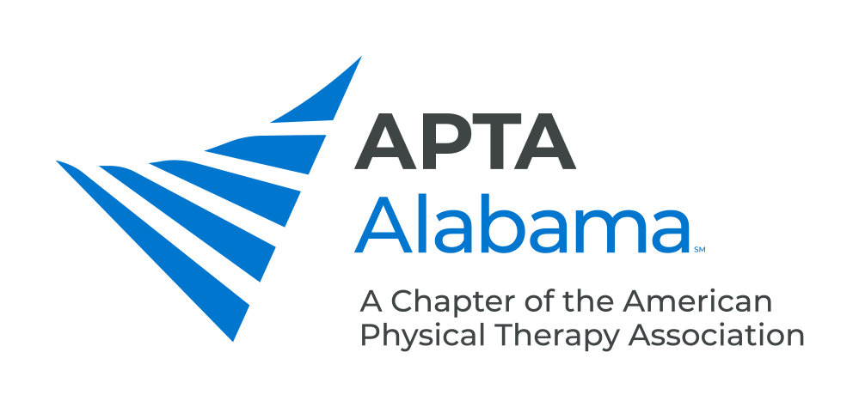
CHAPTER COUNCIL REPORT

Office, Committee or SIG:
PT Representative at Large
Submitted by: Blair Saale, PT, DPT | Date: 7/19/24
Please list your accomplishments since the last report:

- Established new Leadership Team for Alabama Student SIG in conjunction with the Student Council Representative.
- Plan to coordinate first meeting of SSIG 7/25/24 with plan to discuss promotion of the Annual Conference and establishment of student conclave (goal within next calendar year).

