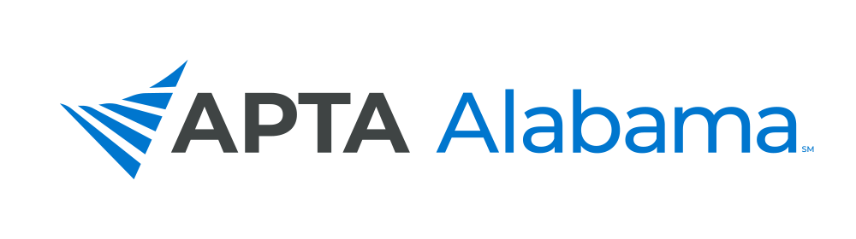
2024 STUDENT CONCLAVE

The University of Alabama at Birmingham
SCHOOL OF HEALTH PROFESSIONS
Saturday, NovEMBER 2, 2024

EXHIBITOR REGISTRATION DEADLINE – OCTOBER 23 (LIMITED SPACE AVAILABLE)

Company Name: _________________________________ Contact Name: ________________________________
Address: _______________________________________________________________________________________
City/State/Zip: ____________________________________________________________________________________
Phone: ___________________________ E-Mail: _______________________________________________________
Booth Attendee Name(s) Up to 2: ___________________________________________________________________

Booths Assigned by Registration Order

Exhibit Space:

  - Single: $300 (Includes 2 Booth Attendees)
  - Double: $575 (Includes 2 Booth Attendees)
  - Additional Booth Attendees: $25 Each

Sponsorship Opportunities - $500 Each

- Lanyards (1 opportunity – Sponsor Provides Lanyards)
- T-Shirt (Logo on T-Shirt – Multiple Opportunities)
- Coozies (1 opportunity – Sponsor Provides Coozies)
- Breakfast (2-3 opportunities)
- Lunch (2-3 opportunities)
- PT Night Out (2 opportunities)
  - Catering
  - Drink Tickets

PLEASE PAY BY CREDIT CARD HERE

Make Checks Payable To: Alabama Physical Therapy Association
(Send this Form to info@ptalabama.org to Reserve Your Booth
Send Check to the Address Below)

SCHEDULE FOR EXHIBITORS

10:10 am – Noon Exhibitor Set-Up

12:15 – 2:00 pm Exhibit Hall

After 2:00 pm Exhibitor Tear Down

